

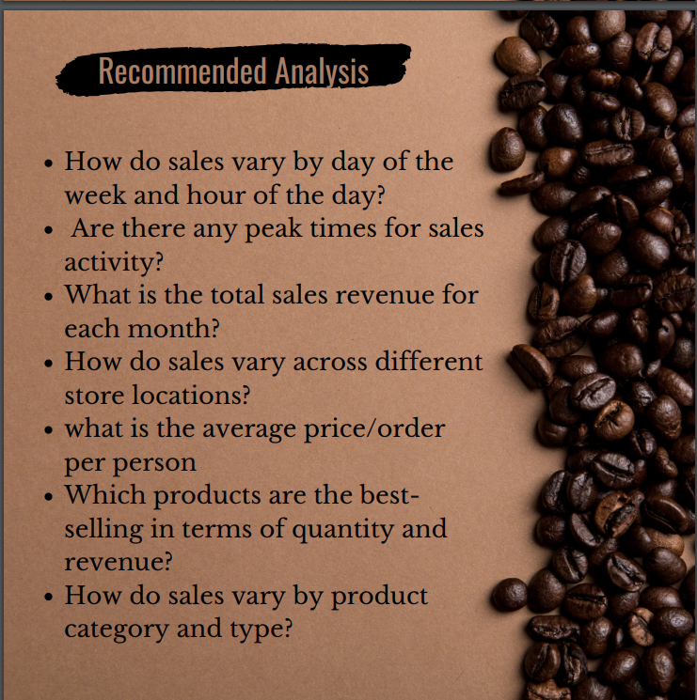

**Coffee Shop Sales Analysis**

**1. How do sales vary by day of the week and hour of the day?**

* **By hour:** Sales peak between **8 AM – 10 AM**, aligning with morning coffee demand. After 11 AM, orders drop steadily throughout the day.
* **By day:** Orders are highest on **Wednesday, Thursday, and Friday**, showing strong midweek demand. The lowest sales are on **Tuesday**.

**2. Are there any peak times for sales activity?**

Yes. The **peak sales activity is in the morning (8–10 AM)**. Midweek (Wed–Fri) also sees the highest overall orders.

**3. What is the total sales revenue for each month?**

From your pivot:

* **March:** $16,136.08 (only one month’s data is shown).

**4. How do sales vary across different store locations?**

* **Astoria:** $5,173.96 revenue
* **Hell’s Kitchen:** $5,573.19 revenue (highest)
* **Lower Manhattan:** $5,388.93 revenue

👉 Hell’s Kitchen performs slightly better than the others, but overall sales are fairly balanced across locations.

**5. What is the average price/order per person?**

* **Average Bill/Person:** $4.63
* **Average Orders/Person:** 1.42

**6. Which products are the best-selling in terms of quantity and revenue?**

* **By revenue (top categories):**
  + Coffee: $6,299.70
  + Tea: $4,616.25
  + Bakery: $1,926.20
* **By revenue (top 5 items):**
  + Barista Espresso: $2,145.15
  + Brewed Chai Tea: $1,938.40
  + Brewed Herbal Tea: $1,138.00
  + Gourmet Brewed Coffee: $1,136.40
  + Hot Chocolate: $1,672.75

👉 Coffee and Tea dominate both category and product sales.

**7. How do sales vary by product category and type?**

* **Coffee** contributes the most revenue ($6,299.70).
* **Tea** is the second highest ($4,616.25).
* Other categories like **Bakery** ($1,926.20) and **Drinking Chocolate** ($1,672.75) follow.
* Smaller contributors include Loose Tea, Flavours, Branded, and Packaged Chocolate.